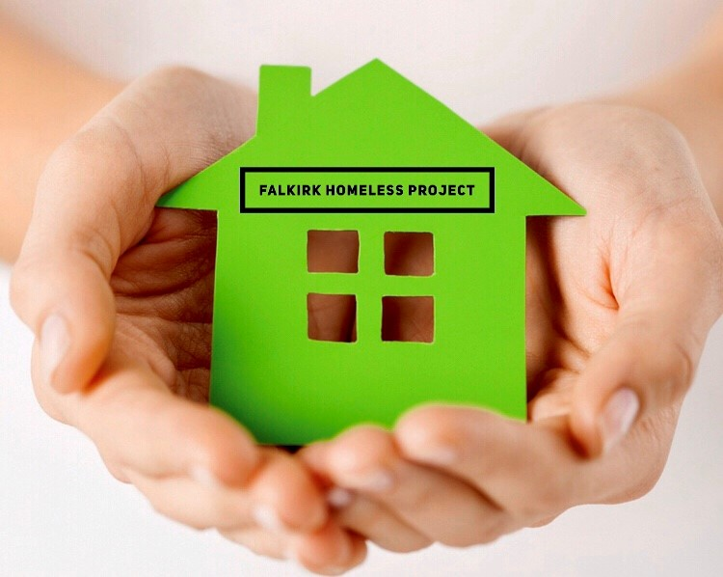
Falkirk Homeless Project has been helping homeless individuals and families to relocate into new homes for over 21 years.

We offer small grants for those gaining access to new homes, those disadvantaged by poverty, through a physical disability or learning difficulty to help with the basics.

If you need support and think you qualify, or would like more information, please discuss it with your support team, housing staff or consider a self-referral.

If you think you qualify for a starter pack grant – please complete the basic details below - or ask your support team to help.

Please send completed applications to:
Falkirk Homeless Project by email to fhpfalkirk2@aol.com
Tick as appropriate below.
Grant Application- Homeless Resettlement ☐ Disabilty ☐ Hardship ☐

Name: |  |  | Support Team Contact:
Property |  |  | Support / Housing Signature or Team:
Postcode: |  |  | Support Contact No:
Telephone No: |  |  | Department Stamp:
Individual / Family Application:
Applicant Signature: |  |  | Date:
Date:
Comments:

